**Defect Report – Manual QA Assignment**

Hi QLub Team,   
  
This document summarizes all the defects identified during the manual testing of the restaurant QR-based application, based on the user stories provided in the assignment.

### **Defect ID: D-01**

**User Story**: User Story 1 – View Menu  
**Title**: Opening multiple tabs with the same QR link caused a session error (503 error in network when checked)  
**Steps to reproduce:**1. Open the QR Code in many tabs and click the menu button  
2. Verify behavior and UI load  
**Expected Result**: Each tab should independently show the menu without conflict.  
**Actual Result**: Some tabs showed a blank screen or an error after loading.  
**Severity**: Medium  
**Type**: Session Handling  
  
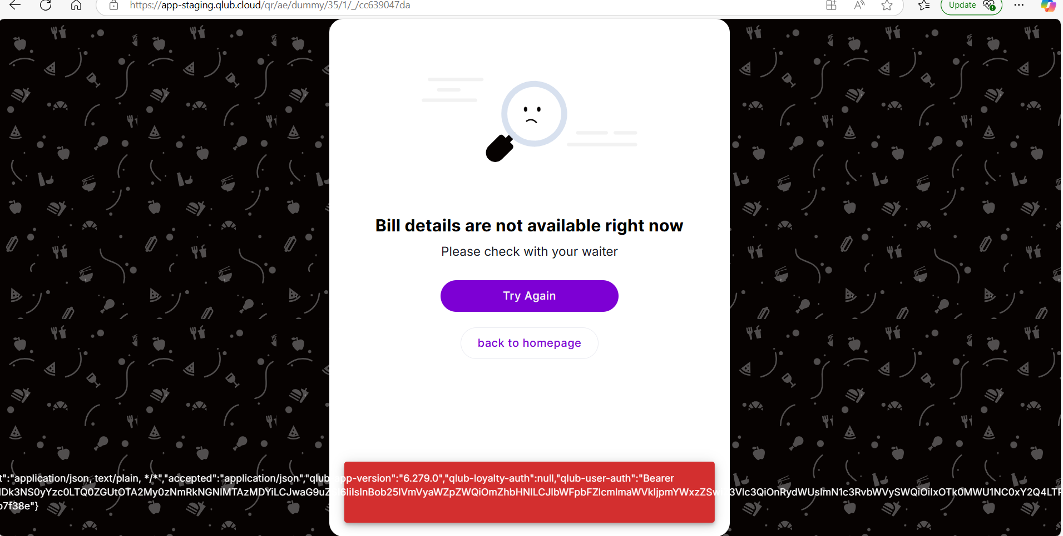

(After closing all the tabs and restarting the browser, and after some waiting time, the above defect was resolved.)

### 

### **Defect ID: D-02**

**User Story:** User Story 1 – View Menu  
**Title**: Loyalty API call returns 401 Unauthorized  
**Description**: Request to /programs?enabled=true returns 401 when refreshing the menu page.  
**Expected Result**: Loyalty program info should load without authentication failure.  
**Actual Result**: 401 error shown in DevTools; no user-facing error or fallback.  
**Severity**: Medium  
**Type**: Backend/API Failure  
  
  
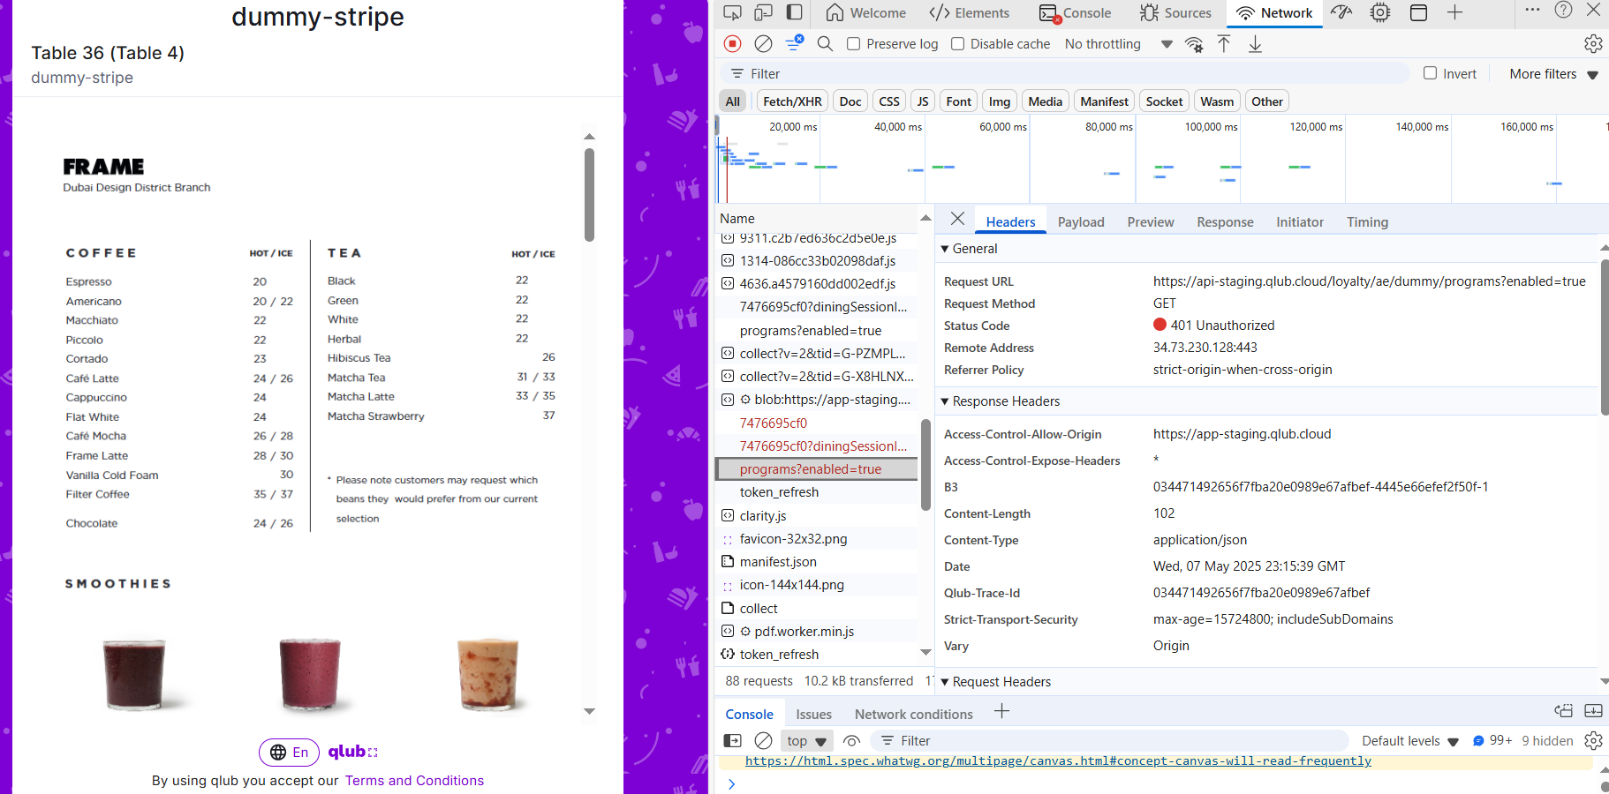

### **Defect ID: D-03**

**User Story**: User Story 1 & 2 – Table Number  
**Title**: Two table numbers are shown on the bill/menu screen  
**Steps to reproduce**:   
1. Open QR  
2. Click Pay now/ Click View Menu  
3. Check the top corner for the table name

**Expected Result**: The correct table number should appear consistently, matching the scanned QR.  
**Actual Result**: Mixed table references shown.  
**Severity**: High  
**Type**: UI Data Mismatch

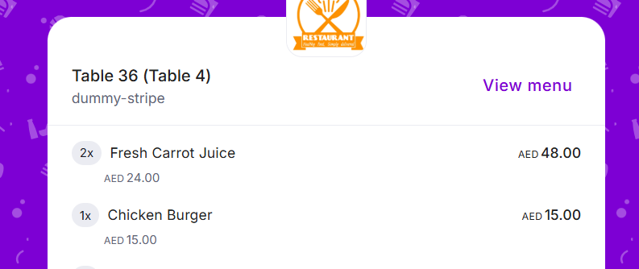

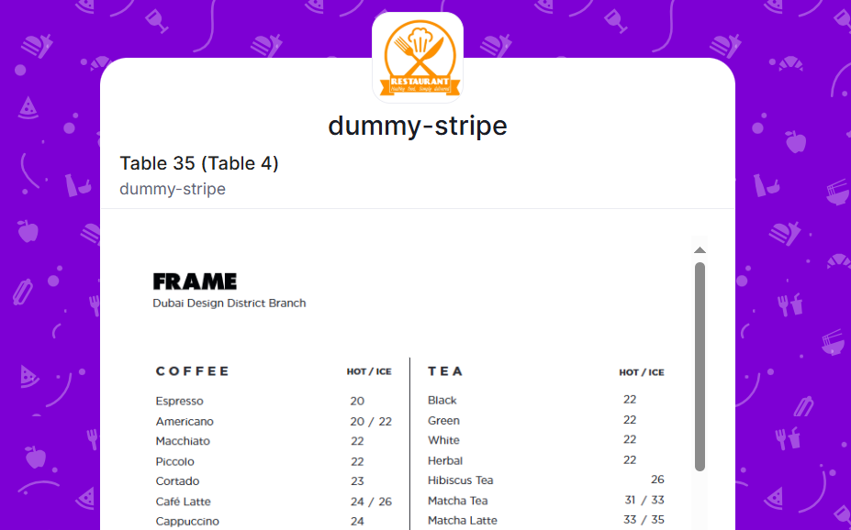

**Defect ID: D-04**

**User Story:** User Story 3 – Payment Options **Title:** Saved card autofill fails – backend returns 404  
**Steps to reproduce:**1. Open QR  
2. Click Pay now  
3. Click inside the card number fieldThe API call /saved-card-details returns 404 when the payment screen loads.  
**Expected Result:** Saved card suggestions should be retrieved or hidden gracefully.  
**Actual Result:** Backend request fails, and no fallback is shown. **Severity:** Medium **Type:** API Failure  
  
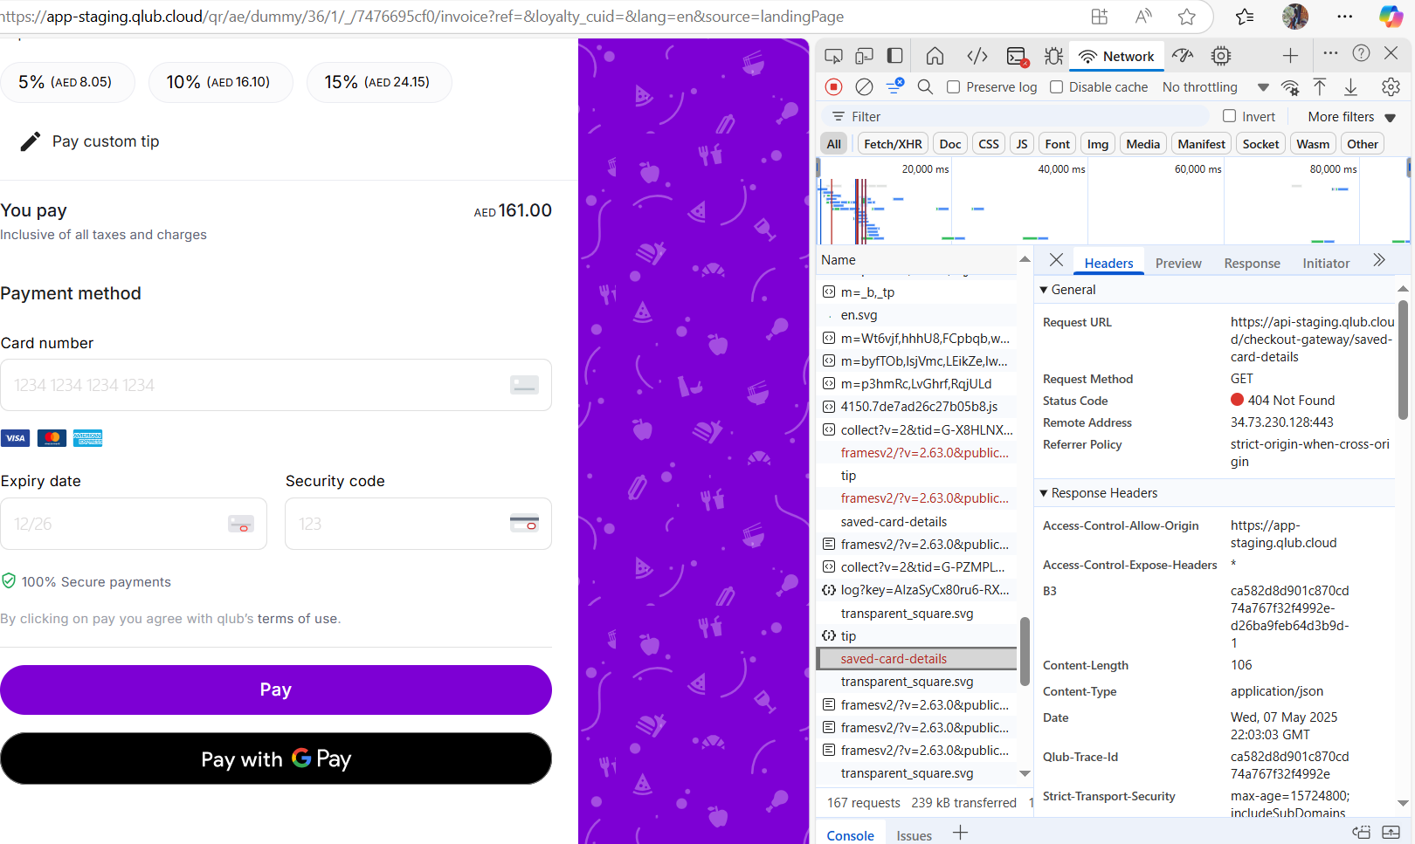

### **Defect ID: D-05**

**User Story:** User Story 3 – Payment Options **Title:** Terms and conditions link opens an empty form  
**Description:** The link for “terms of use” on the payment screen opens a form that appears blank or not populated.  
**Expected Result:** Terms and conditions should be shown clearly in the opened link**.  
Actual Result:** A blank or placeholder page opens. **Severity:** Low **Type:** Content/Legal Compliance

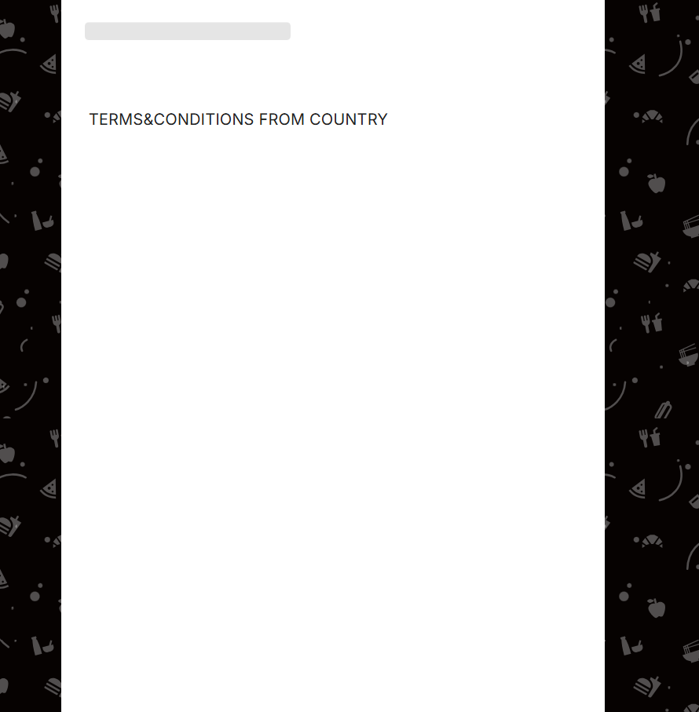

### **Defect ID: D-06**

**User Story**: User Story 1 – View Menu  
**Title**: Menu items do not match items in the bill  
**Description**: Items listed in the final bill (e.g., Onion Soup, Sweet corn soup) are not visible or searchable in the menu.  
**Expected Result**: All billable items should exist in the visible menu to allow validation.  
**Actual Result**: Bill items are not reflected in the available menu categories.  
**Severity**: Medium  
**Type**: Data Consistency

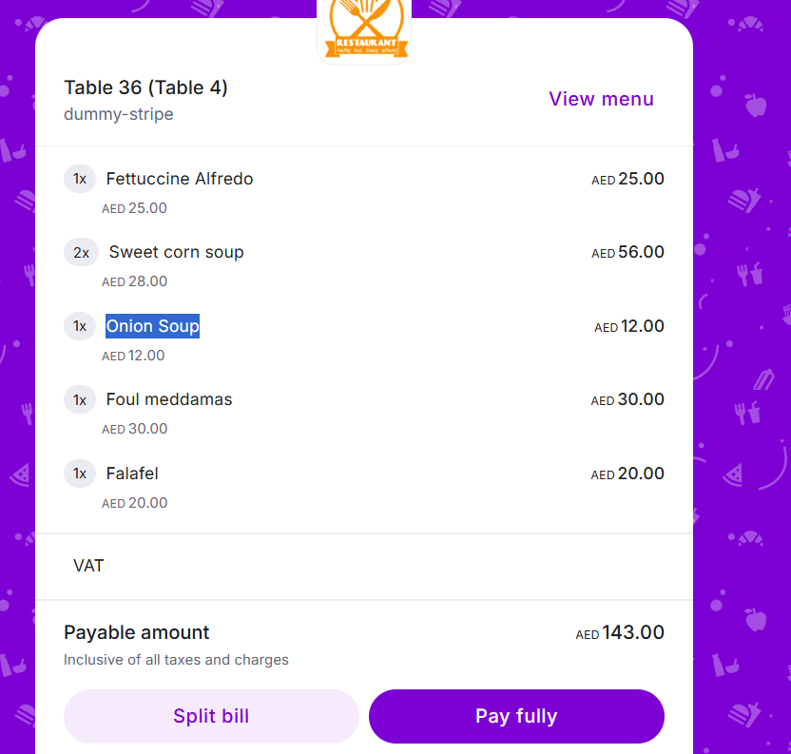

### **Defect ID: D-07**

**User Story:** User Story 1 – View Menu **Title:** Menu items display prices without currency symbol **Description:** Food prices in the menu are displayed as plain numbers (e.g., 34, 55) without the corresponding currency symbol. This can confuse users regarding the currency being charged. **Expected Result:** All food prices should include the appropriate currency symbol (e.g., AED 34.00, AED 55.00) for clarity.  
**Actual Result:** Prices are displayed as plain numbers without any currency symbol.  
**Severity:** Medium  
**Type:** UI/UX Consistency

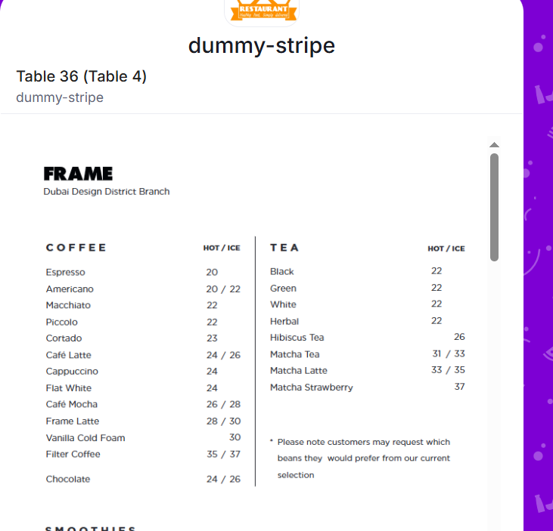

### **Defect ID: D-08**

**User Story:** User Story 3 – Payment Process **Title: The** Card number does not have spacing for better readability  
**Description:** The entered card number appears as a continuous string (e.g., 1234123412341234) instead of being formatted for better readability (e.g., 1234 1234 1234 1234). This can make it difficult for users to verify or enter their card details.  
**Expected Result:** Card number should be displayed with spaces after every four digits (e.g., 1234 1234 1234 1234).  
**Actual Result:** The Card number appears as a single continuous string without any spacing.  
**Severity:** Low  
**Type:** UI/UX Consistency  
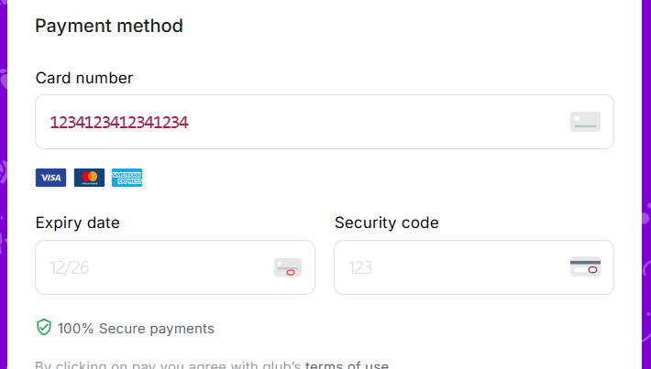

**Defect ID: D-09**(This bug is not found under manual user story testing, but was found after the automation assignment, as under manual user stories for story 4, it only requires checking the visibility of the split options.)

**User Story:** User Story 4 – Payment Split Process  
**Title:** Missing "Edit Split" and "Pay Fully" Buttons After Successful Split  
**Description:** After completing a successful payment split, the "Edit Split" and "Pay Fully" buttons are missing. This prevents users from making full payments if needed.  
**Expected Result:** After a successful payment split, the "Edit Split" and "Pay Fully" buttons should remain available, allowing users to make further adjustments or complete full payments.  
**Actual Result:** The "Edit Split" and "Pay Fully" buttons are not displayed after a successful split, limiting user options.  
**Severity:** Medium  
**Type:** UI/UX Functionality

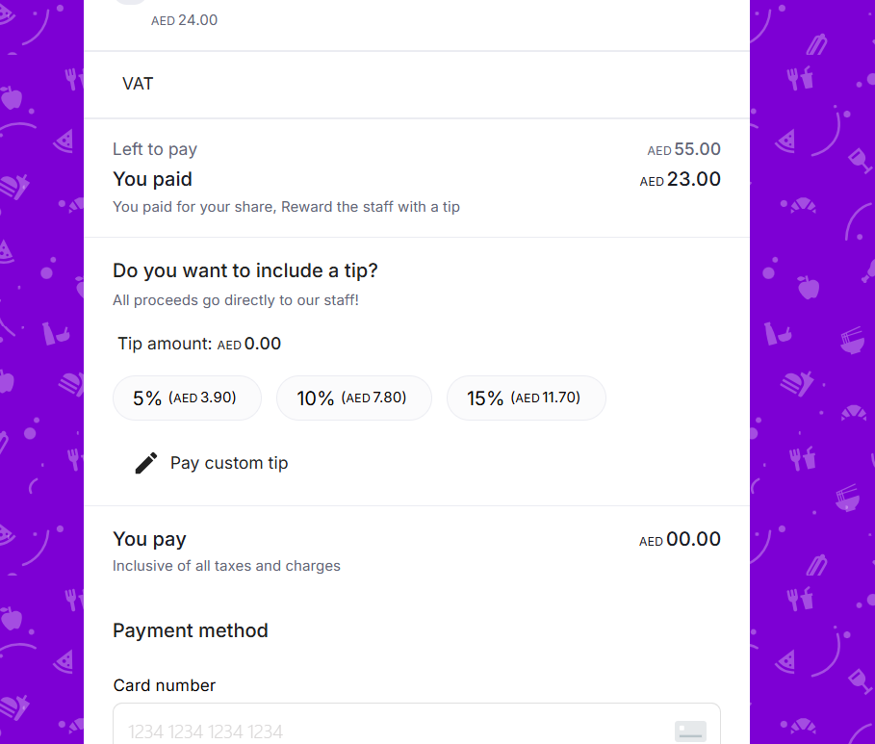  
Regards,  
Amasha Thilakarathne